**Lesson 06 Demo 2**

**Demonstrate YAML Scripting**

**Objective:** To install NodeJS using YAML scripting

**Pre-requisites:** You need to have Ansible installed in order to proceed with this demo. If you don’t have it installed, refer to demo 1 of lesson 7.

**Tools required:** Ansible

**Steps to be performed:**

1. Create a playbook

2. Add YAML script to the playbook to install node

3. Run Ansible YAML script

**Step 1: Create a playbook**

1.1 Use the below command to create a ***node.yml*** file

***sudo vi node.yml***

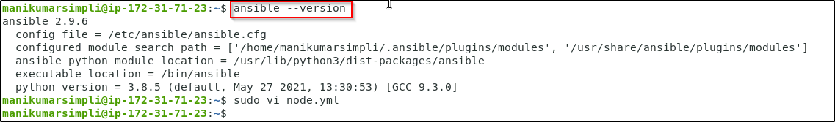

1.2 Establish SSH key pair in linux system to have SSH connectivity with localhost using the following commands:

**ssh-keygen -t rsa** (Press **Enter** when asked for File and Paraphrase details)

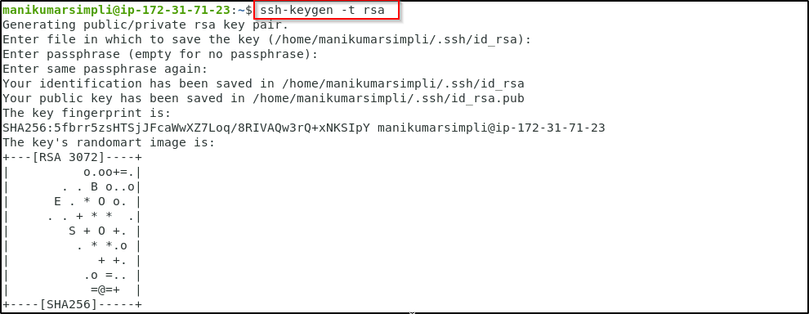

**cat .ssh/id_rsa.pub >> .ssh/authorized_keys**

**ssh localhost -p 42006**

(Type **yes** when prompted)

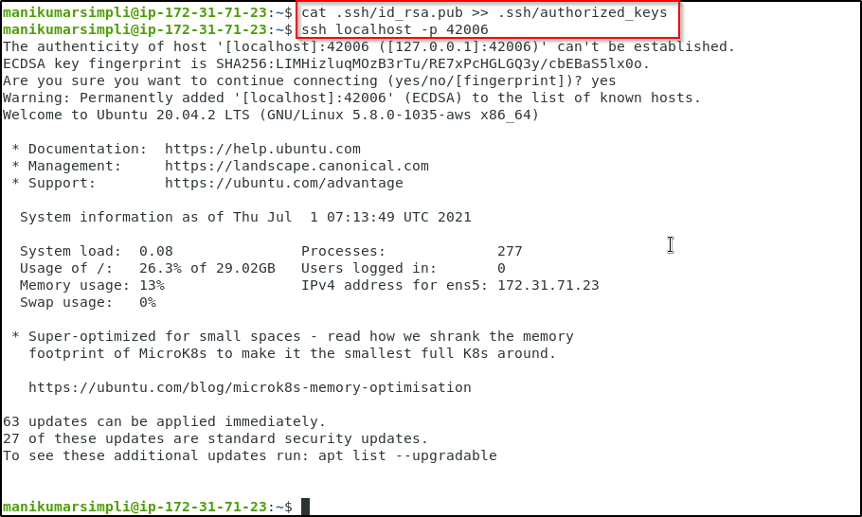

1.3 Now, add the host localhost in ansible host file ***/etc/ansible/hosts***

***sudo vi /etc/ansible/hosts***

1.4 When the file opens, add the below two lines of the code at the end of the file:

***[webservers]***

***localhost:42006***

**Step 2: Add YAML script to the playbook to install node**

2.1 Open the node.yaml file by using the below command 2.2 and then add the following code

***sudo vi node.yml***

Copy paste the below code:

**---**

**- hosts: webservers**

**become: true**

**tasks:**

**- name: add apt key for nodesource**

**become: true**

**apt_key: url=https://deb.nodesource.com/gpgkey/nodesource.gpg.key**

**- name: add repo for nodesource**

**become: true**

**apt_repository:**

**repo: 'deb https://deb.nodesource.com/node_0.10 {{ ansible_distribution_release }} main'**

**update_cache: no**

**- name: install nodejs**

**become: true**

**apt: name=nodejs**

2.2 Save the file and exit using **shift+esc+:** and then type wq

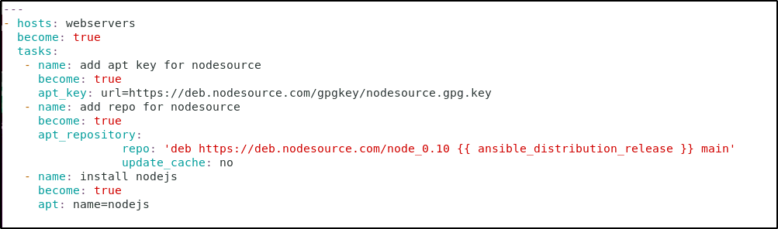

**Step 3: Run Ansible YAML script**

3.1 Run ***node.yaml*** file using below command:

***ansible-playbook node.yml***

